**Accounts Payable Automation**

**Version: 2**

**Business Requirements v.1**



Nexelus USA  
New York, NEW YORK (NY)  
646-558-1950

December 14, 2020

|  |  |  |  |
| --- | --- | --- | --- |
| **Revisions** | | | |
| **Date** | **Version Number** | **Revised By** | **Reason for Changes** |
| 2020-12-14 | v.1 | Imran Rahman | Initial Draft |
| 2020-12-23 | v.2 | Tao Lin | Database model update |
| 2021-01-11 | v.3 | Imran Rahman | Revision, use cases and process definition |
| 2021-02-01 | v.5 | Zeeshan Akhtar | ERD added. |

|  |  |
| --- | --- |
| **Open Items** | |
| **Location** | **Description** |
|  |  |

1. Introduction 5

Project Based/Production, Non-Billable and Overhead Vendor Invoices 5

Enhancements for media invoices and general architecture 5

2. System Requirements, Scope, Assumptions 6

3. System Data Flow Design 6

4. Database Design 7

5. Non-Media Vendor Invoice Processing 11

6. Use Cases for Non-Media Invoices 17

7. Workflow Step 1 - System Initiation 19

8. Workflow Step 2 - AP Invoice Mapping 19

9. Workflow Step 3 – Scanner 19

10. Workflow Step 4 – Invoice Requests 20

11. Workflow Step 5 – Create Manual Invoice 20

12. Workflow Step 6 – Invoice Approval and Posting 20

13. User Menu 20

14. Company Configuration 21

15. Approval Setup 21

16. Multi-Currency Support and Mapping 21

17. Manage Non-Mapped Invoices 21

18. Manage Invoice Models 21

19. New Invoice Model Setup 21

20. New Invoice Model Setup (Test) 21

21. Invoice Model Setup - Request_<N> 21

22. Manage Invoice Documents 21

23. Review Invoice Document 22

24. Additional Documents 22

# Introduction

This document specifically focuses on Version 2 of AP Automation system (AKA AP workflow). While version 1, released in Dec 2020, focused on addressing basic requirements around AP automation of workflow for media business, version 2 is to handle “non-media” accounts payable invoices in addition to developing Nexelus proprietary AI and machine learning algorithm and patterns to predict the “best” solution in resolving discrepancies for all types of invoices. Non-media AP invoices include project based, referred to as “production”, invoices along with non-billable and overhead (rent, utilities, etc.) vendor invoices.

## **Project Based/Production, Non-Billable and Overhead Vendor Invoices**

In media advertising business, insertion orders (IO) are required to process any media vendor invoice. However, for this category of vendor invoices a purchase order (PO), equivalent to an IO, is not always required or the client may not be using purchase orders through their project based/ERP systems. For Nexelus system following three fields are required to process this category of invoices:

* Project/Job code (level2)
* Activity code (level3 – however this level will not be available in non-Nexelus/ERP environments)
* Expense Type (printing, editing, retouching, meals, etc. In Nexelus, there is a set of valid expense types that are available for a specific level2/level3 combination)

If the PO is stamped then it maps to level2/level3/expense type combination, like media invoices and IO numbers. Please note that companies like 360i and HY offer both Media and Non-Media (production) services to their respective clients. Hence, the design needs to cater to both types of processing, which will potentially carry different data elements and can have different workflow in-terms of discrepancy resolution and approval levels, etc. However, the basic flow of data processing will be the same as it is implemented in the media AP workflow system, i.e., creation of models, routing for discrepancy resolution and approvals, and creating AP vendor invoice records in the ERP system along with pushing the attachment.

## **Enhancements for media invoices and general architecture**

For version 1 of the software, Nexelus relied on AWS Textract to scan and read data from a “picture” or a PDF, Version 2 will include certain predictability models to predict and assign data elements, so the workflow moves to the next action level. Following are a couple of examples/scenarios:

* **Discrepant Invoices**: Version 1 requires “manual” routing by an “admin” to route the invoice in question to someone who the admin thinks should be able to resolve the issue by typically assigning an IO number for further workflow processing. This is typically done by an admin personnel by reading the Advertiser name and/or campaign description from the scanned invoice. This step must be handled by the system using AI and machine learning. We have several data elements in the “ERP” provided data set and we need to use “already” processed data, advertisers name, campaign and media plan description, month of service on the invoice, along with IO data that provides IO dates of placements, campaign name, etc. System should be able to predict and route this type of discrepant invoices to relevant team member (employee).
  + AI to use prediction and subsequent “action of success” and/or rerouting from saved dataset in case machine did not route to correct individual originally and then learn the pattern for future handling of the similar scenario. This type of learning must be shared across all clients.
* **System to pick IO number** even if the IO/PO number is not on the vendor invoice. Building on the point above, system should be able to locate “most suited” IO number. Visual indication of level of “predictability” must be preserved and displayed

# System Requirements, Scope, Assumptions

During phase I (version 1) we did not handle Registration, Trial Accounts, Licensing, Subscription and Billing setup through the user interface. This will still be the case with version 2 as all these elements will be maintained by Nexelus personnel on database level.

Invoice input documents (scanned images or generated) are supported only in PDF, JPEG or PNG formats. AP Automation system will not convert input files from other formats.

AP Automation System is designed as totally disconnected, self-sufficient application but it does require data feed from the other system – client’s ERP system, not in a real-time though. Please note that certain fields, especially for non-media, must be configurable as the “activity/level3” is unique to Nexelus. Most systems have project/job and expense type as the hierarchy. In some legacy systems overhead can be coded to “client code” and expense types without any tagging of a project code.

No change to AP Automation database design with reference to multi-tenant database approach using Amazon Aurora MySQL database engine initially deployed on a single database instance. Common schema to maintain sharable set of model definitions and corresponding reference data will be reused across client’s dedicated schemas. Each client schema will maintain client setup information, routing setup data, processed invoices, etc.

# System Data Flow Design

Below is high level diagram that shows overall data flow within an application (no change from version 1).

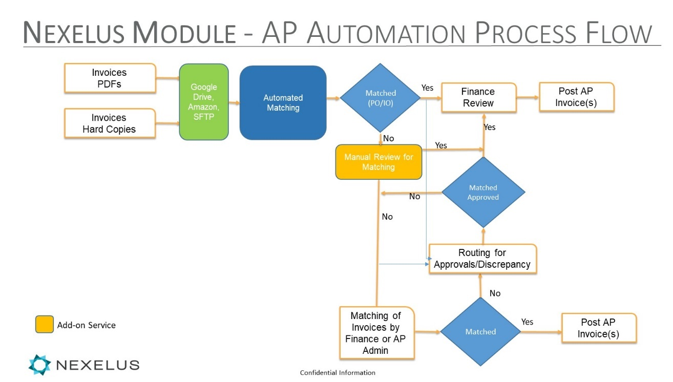

# Database Design

New tables, along with changes to existing tables will be discussed and documented.

Section below list data elements that will read into the AP workflow to handle non-media invoices





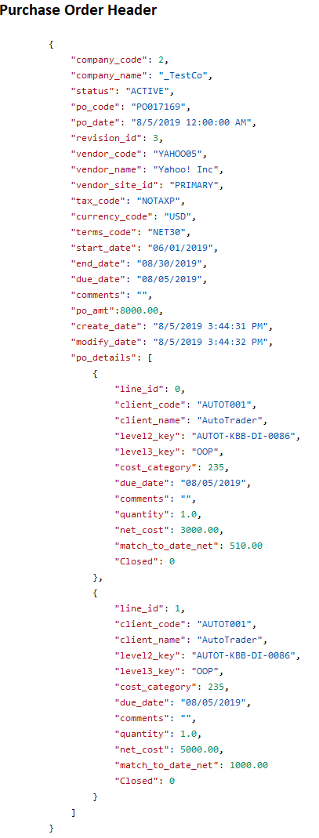

## Database Design changes

Following tables have been introduced in client database along with two statuses tables in Common Database.

1. apad_level2
2. apad_level3
3. apam_cost_types
4. apad_cost_codes
5. apautomation_common.apai_level2_status
6. apautomation_common.apai_level3_status

Some missing foreign key constraints have also been added.

1. Foreign key constaint with apad_po_header and apad_po_resources
2. Foreign key constaint with apad_po_header and apad_po_media_delivery

# Non-Media Vendor Invoice Processing

There are typically four (4) types of media invoices:

* Client Billable
* Client Non-Billable
* Overhead
* General Non-Billable

In addition to above, applicability of purchase orders as it relates to “requirement” vary based on type of invoice above (typically through different job types) and/or vendor. For example, you do not issue purchase orders to FedEx, UPS, etc.

Below are instructions for entering a non-media invoice in Nexelus. Purpose here is to fully understand the processing to avoid simple mistakes in programming:

**Voucher Entry**

**Data Entry>>Voucher Entry**

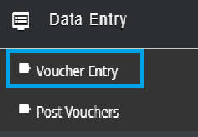

When is a purchase order required in voucher entry?

* Billable job

*Note: Purchase Orders must be open, approved and printed to access in voucher entry*

Otherwise, purchase orders are **optional**.

To establish a new voucher, click the **New** button in the upper right corner of the voucher screen and follow these steps.

**New Voucher Entry – No Purchase Order Steps**

1. Vendor Code
2. Invoice No.
3. Applied Date
4. Invoice Date
5. Due Date
6. Upload Document
7. Add Detail Lines - Job, Activity, Expense Type, Quantity, Cost, Description
8. Save

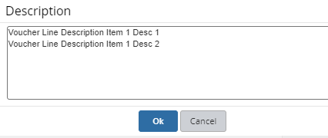

Vendor Code

Click search button to look up and select vendor.

*Note: Vendor must be added and active in D365/Oracle/etc. to use in Nexelus.*

Invoice No.

**In AP automation process, system will check for duplication in the same exact manner that is done for media invoices**

Enter vendor invoice number.

Click ? to check invoice number for duplication. If invoice number already exists for the vendor, message will indicate duplicate. If not, green check mark will display.



Applied Date

Applied date will default based on current period setting in Nexelus. Can set to a future period if that period is active in Nexelus. However, applied date cannot be later than invoice due date.

Note: Depending on month end closing procedures, the current period date in Nexelus may not be switched over until month end processing is complete. For vouchers intended for the new month, the date must be overridden.

Invoice Date

Invoice date defaults to current date. To override, select from calendar or enter as mmddyyyy.

Due Date

Due date will calculate based on vendor terms and invoice date.

Upload Document

Documents can be uploaded associated with the voucher before the voucher is posted. **This will come from the AP automation system**

Add Detail Lines - Job, Activity, Expense Type, Quantity, Cost, Description

Click **Add Line** Button in voucher detail section

Job look up and select

Activity expense activities from the job will be listed for selection

Expense Type The expense types will be restricted to those included in the expense group associated with the job activity selected.

Quantity Defaults to 1. Can be overridden

Cost Enter unit cost

Description Optional line description/comments. This can print on client billing.

GL Account After all entries above are made, the GL account will display.

Note: GL account cannot be changed in voucher entry. If appears incorrect, put voucher on hold and research settings that create the GL account. (Expense group setting in job and expense type.)

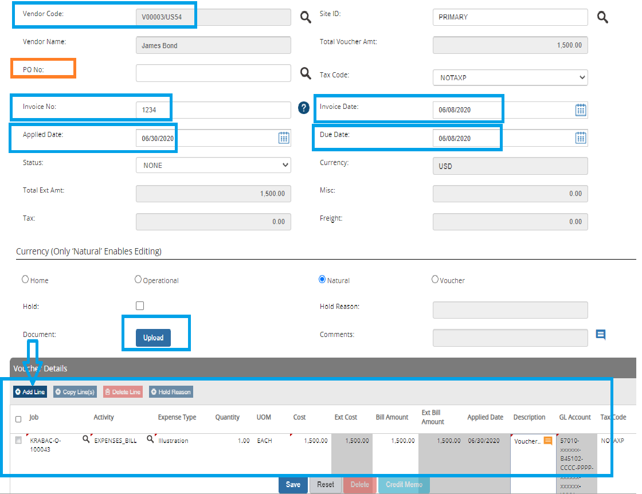

Save Voucher

Click **SAVE** at bottom of the screen.

**Note: Vouchers created from the AP workflow automation comes in as “un-posted” vouchers.** Vouchers can be changed or deleted until they are posted. Once posted, the voucher needs to be credited to be reversed

**New Voucher Entry with Purchase Order**

The difference in entering a voucher with a purchase order is in the voucher details section where the job, activity, expense types and cost will populate from the purchase order automatically. If the invoice is for a different amount than the PO, a lesser amount can be entered. If a greater amount is needed beyond the PO tolerance setting, the PO would need to be revised.

Note: PO tolerance – A percentage of PO tolerance can be set to allow amounts on the voucher greater than the PO. This is a system-wide setting.

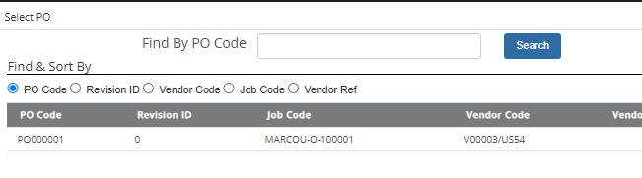

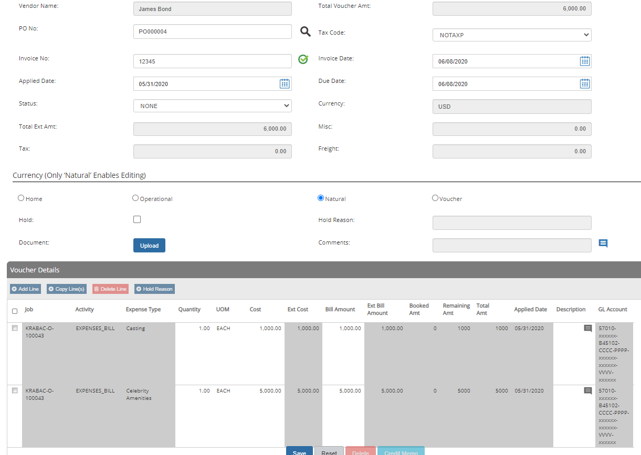

**Post Vouchers**

After vouchers have been entered, they must be posted to create entries in D365.

**Data Entry>>Post Vouchers**

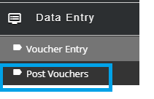

**Steps for Posting Vouchers**

1. **Search for unposted vouchers**
2. **Select vouchers to post**
3. **Post**

**Search for unposted vouchers**

Click **Search** button in upper right corner of Post Vouchers screen.

**Select vouchers to post**

Use left and right arrows buttons between “Available” and “Selected” sections to move vouchers to/from selected.

**Post**

Click **Post** button on bottom of screen.

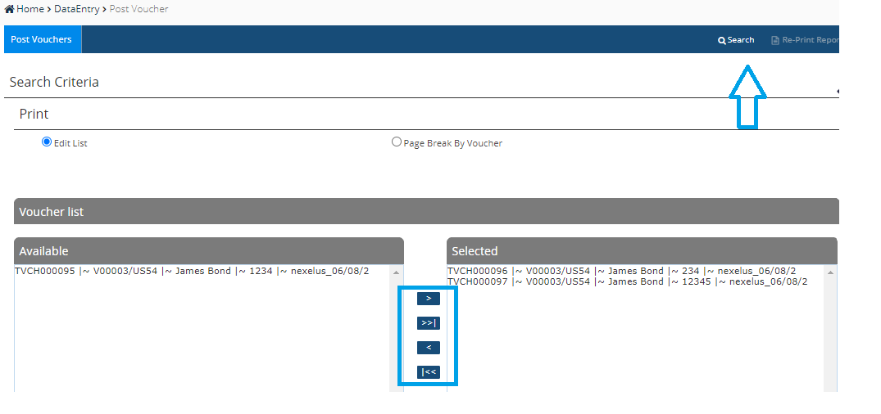

After vouchers post, window pops up indicating number of vouchers posted and number of vouchers not posted due to errors. Click **OK** to proceed to generation of Posted Vouchers Report. Report will display in new browser tab.

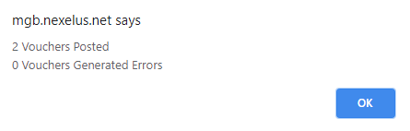

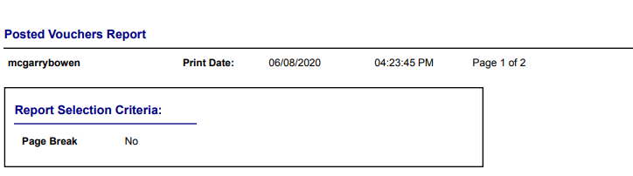

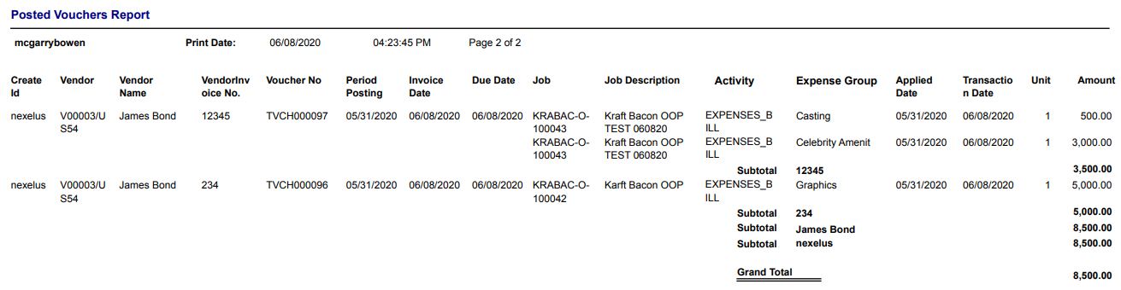

**\*\*\*\* Note that Media and Non-Media Invoices gets created in Nexelus in same set of tables with certain flags and values identifying invoice being a media invoice or a non-media invoice.**

# Use Cases for Non-Media Invoices

|  |  |
| --- | --- |
| **Use Case** | |
| **Title** | Process Production Vendor Invoice |
| **Description** | Defining the full workflow of processing a production vendor invoice. |
| **1** | Vendor sends a vendor invoice to the AP production email address |
| **2** | Once the invoice is picked up and processed by the system an email will be sent out to the relevant users based on the following criteria |
| **2a** | If invoice is not scanned successfully, meaning no matching model is found. Then an email should be sent out to the admin user for further processing. |
| **2b** | If invoice is successfully scanned with a matching model and it is missing the required information. Then an email should be sent out to the admin user for routing. However, if there is a PO or level2 value found, then it should send an email to the PO or level2 resources. |
| **2c** | If an invoice is successfully scanned with a matching model and it has the required information listed below for the two vendor invoice types. Then email will be sent to the PO resources for vendor invoice with PO or level2 resources for vendor invoice that has valid level2 and without PO.  • Vendor Invoice with PO  - Vendor, Invoice Number, Invoice Date, Due Date, Payment Terms, PO, and Currency.  - Based on PO in the header. The following information will be populated in detail   - level2_key, level3_key, expense type, description and amount  • Vendor Invoice that has valid level2 and without PO   * vendor is marked as "NOPO" in the vendor comment section of the Nexelus data feed and level2_key is found. * if the vendor does not have “NOPO” set. Then the system will check the level2_key for PO require flag. If PO is not required then it validate successfully. * These fields needs to be defined for the validation to be successful.   + Vendor, Invoice Number, Invoice Date, Due Date, Payment Terms and Currency level2_key, level3_key, expense type, description (optional) and amount. |
| **3** | User will login into the system and review the invoice in the system. Either through the link in the email or by checking their dashboard. If user have access to Manage Invoice Documents, they can review it there as well. |
| **4** | For production invoices there are two types of invoices, invoices with PO and no PO. Depending on the type of invoices the user will follow different process to resolve the discrepancy. |
| **4a** | Vendor invoice with PO - Please note that there can only be one PO per invoice |
| **Scenario 1** | if the invoice is missing the following information for vendor invoice with PO then it should be routed to a user to fill in the necessary information:  - Vendor, Invoice Number, Invoice Date, Due Date, Payment Terms, PO, and Currency.  - level2_key, level3_key, expense type, description, and amount |
| **Scenario 2** | The invoice matched to a PO but there is no matching expense type in the detail. User will need to review the PO details and select the expense type that is part of the PO. For example, PO has 2 lines and invoice has 1 line. User will need to select the correct PO line manually. |
| **Scenario 3** | The invoice matched to a PO but there is no matching level2, level3 and expense type in the detail. This scenario can occur when there is more than one level2 in a PO. In this case user will need to select the level2, level3 and expense type that is part of the PO. |
| **4b** | Vendor invoice without PO |
| **Scenario 1** | if the invoice is missing the following information for vendor invoice without PO then it should be routed to a user to fill in the necessary information:  - Vendor, Invoice Number, Invoice Date, Due Date, Payment Terms and Currency.  - level2_key, level3_key, expense type, description, and amount |
| **Scenario 2** | If the invoice is matched, but it is missing the level2, activity and expense type in the detail. The admin will need to route the invoice to the user that will be able to fill in the missing information. |
| **Scenario 3** | If the invoice is fully matched and the vendor is not marked as "NOPO" and level2/level3/expense type is populated. Then system should check, if the level2 require PO. If the level2 is set to PO required, then system should put this in discrepant. To resolve this issue, user will need to choose the correct level2 that does not require a PO or create a PO in Nexelus and match it in AP Automation system. |
| **5** | User will need to approve the successfully matched or corrected production invoices. This approval chain can be different than the Media Approval chain and it should be separated. |
| **6** | Once, the invoice is approved, finance or admin user will need to post the invoice to the financial system OR it is automatically posted after the last level of approval. |

# Workflow Step 1 - System Initiation

No change, same as version 1

# Workflow Step 2 - AP Invoice Mapping

As discussed, there will be two separate options for invoice models by introducing invoice type (category) in the user interface as some fields and its dependencies are not relevant, e.g., there is no concept of service term or usage of PO is based on type Project and/or vendor. Vendor invoices from vendors like FedEx and UPS may carry many detail lines across various projects, and details can be in form of sub-group/table. Typically, these type invoices have many pages as part of the invoice. Please request invoice samples from few clients to see the commonality as to which field that they are tracking job codes, etc. Nevertheless, certain fields (typically header) will be common between media and non-media invoices.

# Workflow Step 3 – Scanner

No change, same as version 1

# Workflow Step 4 – Invoice Requests

* TBD

# Workflow Step 5 – Create Manual Invoice

* TBD

# Workflow Step 6 – Invoice Approval and Posting

* For non-media/production invoices. Separate approval process is to be established

# User Menu

Please explore the options of having one dashboard for media and non-media as an option. Finance team or admins may have a preference to have one. And in small companies account managers may be approving media and non-media production invoices. Putting the discussion on Dashboard aside, rest of options should be as below, and controlled by the license key and security rights:

**Media**

* + - Manage Non-Mapped Invoices
    - Manage Invoice Models
    - Manage Invoice Documents

**Non-Media**

* + - Manage Non-Mapped Invoices
    - Manage Invoice Models
    - Manage Invoice Documents

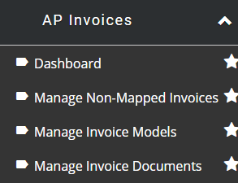

# Company Configuration

TBD. There will be necessary changes

# Approval Setup

Approval setup needs to be set by Invoice Type (category) for media and non-media types.

# Multi-Currency Support and Mapping

We may need to handle multi-currency processing and we should also discuss multi-language support as well

# Manage Non-Mapped Invoices

# Manage Invoice Models

# New Invoice Model Setup

# New Invoice Model Setup (Test)

# Invoice Model Setup - Request_<N>

# Manage Invoice Documents

# Review Invoice Document

# Additional Documents